Complete Subject

✅ What is Complete Subject
# Source: AI Source: Provided by: [Data Path: Persons Table -> ID Column: 1, Name_En Column: Motasem Essam] -> From: [Chatgpt (GPT-4-turbo)] on [8/4/2025]
A complete subject includes:
- The simple subject (main noun or pronoun)
plus
- All modifiers (articles, adjectives, determiners, prepositional phrases, etc.) that describe or limit the subject.

🔹 Key Features:
# Source: AI Source: Provided by: [Data Path: Persons Table -> ID Column: 1, Name_En Column: Motasem Essam] -> From: [Chatgpt (GPT-4-turbo)] on [8/4/2025]
- It tells the full “who” or “what” the sentence is about.
- It includes everything before the verb that relates to the subject.

🔹 Examples:
# Source: AI Source: Provided by: [Data Path: Persons Table -> ID Column: 1, Name_En Column: Motasem Essam] -> From: [Chatgpt (GPT-4-turbo)] on [8/4/2025]
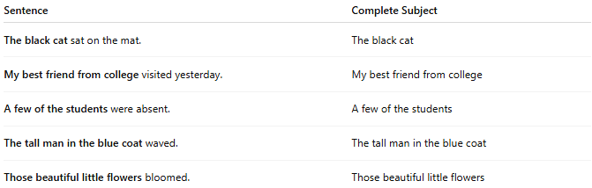
Sentence | Complete Subject
The black cat sat on the mat. | The black cat
My best friend from college visited yesterday. | My best friend from college
A few of the students were absent. | A few of the students
The tall man in the blue coat waved. | The tall man in the blue coat
Those beautiful little flowers bloomed. | Those beautiful little flowers
All the bolded parts are complete subjects because they include the main noun and all its descriptors.

🔄 Comparison with Simple Subject:
# Source: AI Source: Provided by: [Data Path: Persons Table -> ID Column: 1, Name_En Column: Motasem Essam] -> From: [Chatgpt (GPT-4-turbo)] on [8/4/2025]
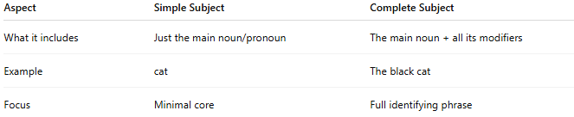
Aspect | Simple Subject | Complete Subject
What it includes | Just the main noun/pronoun | The main noun + all its modifiers
Example | cat | The black cat
Focus | Minimal core | Full identifying phrase

